**Project Team 27**

Sprint #1

Week #3

Team Member Name – Swapnil Makarand Joshi

What I did since the last week scrum?

1. Completed keyboard and mouse activity related learning
2. Explored basics about landscape creation

What I plan to do next week?

1. Learn landscape creation in depth

What blockers I have?

None

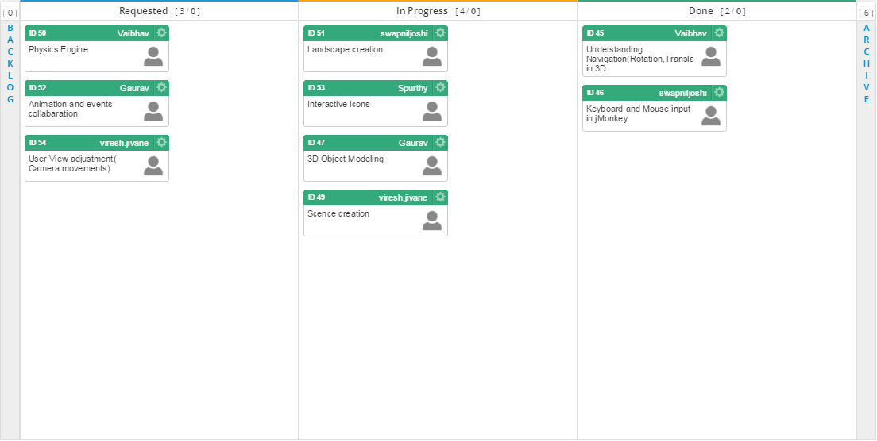

Task board in Kanbanize

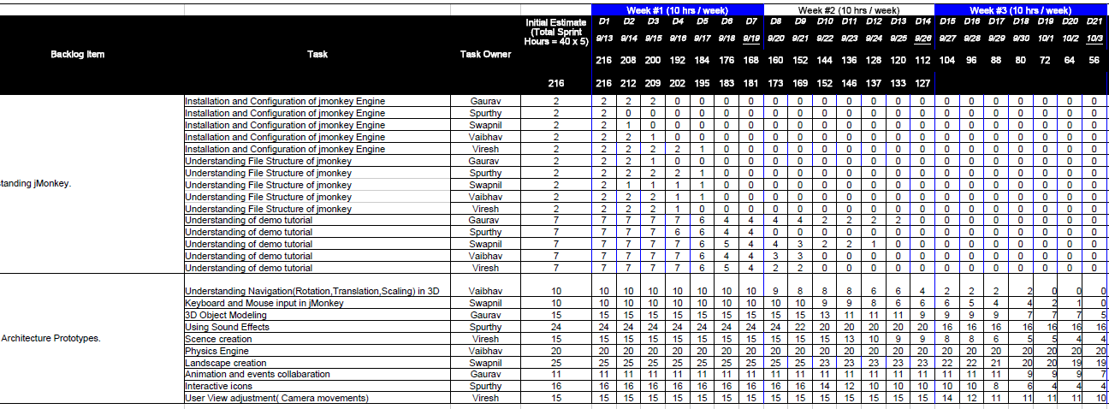

Weekly Standup Report

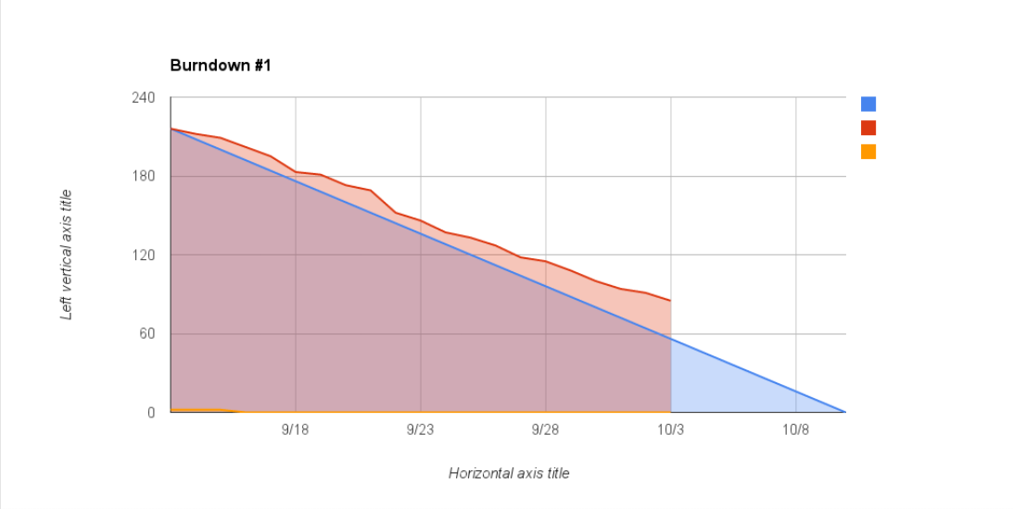

Burndown Chart